TUCSON TRANSIT MANAGEMENT LLC
DBA
SUN TRAN
DEPARTMENT OF PROCUREMENT

AMENDMENT NO. ONE (1)

REQUEST FOR PROPOSAL NO. 24-25-07

DRIVER PROTECTIVE BARRIERS

DATE ISSUED: FRIDAY, January 24th 2025

The referenced document has been modified as per Amendment No. One (1)

Please sign this Amendment where designated and return the executed copy with the submission of your proposal. This amendment is hereby made part of the referenced proposal as though fully set forth there in. Any questions regarding this amendment should be addressed to Gina Feilds, Senior Buyer at (520) 206-8813 or gina.fields@tucsonaz.gov

Department of Procurement, Sun Tran
3920 N Sun Tran Blvd.
Tucson, Arizona 85705
(520) 206-8813 Fax: (520) 293-3442

DRIVER PROTECTIVE BARRIERS

Item One: FTA certification language added:

INSTRUCTIONS TO OFFERORS 6. PREPARATION OF PROPOSAL: B.
- The following language has been added and will replace item (B) in its entirety:

At a minimum, your proposal should include the signed Offer and Acceptance form, signed copies of any solicitation amendments, FTA certifications (filled and signed), completed Price Page and your response to all Evaluation Criteria.

INSTRUCTIONS TO OFFERORS 9. PROPOSAL/SUBMITTAL FORMAT:
- The following section has been revised will replace item (9) in its entirety:

An original of each proposal should be submitted on the
forms and in the format specified in the RFP. Offerors shall also submit one electronic copy on USB Flash Drive in MS Office or .pdf format. . Any confidential information shall be submitted on a separate cd disc or USB flash drive. The original copy of the proposal should be clearly labeled "Original" and shall be single-sided, three hole punched and in a binder. The material should be in sequence and related to the RFP. The sections of the submittal should be tabbed, clearly identifiable and should include a minimum of the following sections: the completed Offer and Acceptance Form, all signed Amendments, FTA certifications (filled and signed), a copy of this RFP document and the Offeror’s response to the Evaluation Criteria including the completed Price Page. Failure to include the requested information may have a negative impact on the evaluation of the Offeror’s proposal.

ATTACHMENT A
- The following language will replace page 26 Attachment A in its entirety:

ATTACHEMENT A

SUBMITTAL REQUIREMENTS
- Detailed response to Scope of Work and Evaluation Criteria:
- Method of Approach
- Qualifications & Experience
- Pricing

- Price Page(s)

- Insurance documents

- Signed Offer and Acceptance Page

- Signed Amendment(s) (If applicable)

- FTA certifications filled out and signed

- Submittal Format:
  - Original copy shall be single sided, three hole punched, in a binder and clear labeled “Original”
  - The sections of the submittal should be tabbed, clearly identifiable and should include a minimum of the following sections: the completed Offer and Acceptance Form, all signed Amendments, FTA certifications filled out and signed, a copy of this RFP document, the response to the Evaluation Criteria and completed Price Page.
  - One electronic copy of the proposal on USB flash drive in MS Office or .pdf format.
  - The electronic copy of the completed price page must be in .xlsx format.
  - Any confidential information shall be submitted on a separate USB flash drive
  - Proposals must be submitted in a sealed envelope or package. The words “SEALED PROPOSAL” with the Request for Proposal Title, Proposal Number, Proposal Due Date and Time and Offeror’s Name & Address shall be written on the envelope or package.
  - Proposals must be delivered to Sun Tran’s Administrative Building 3920 N Sun Tran Blvd Tucson, AZ 85705

- Any additional submittal requirements indicated in the Scope of Work or Special Terms and Conditions (Reports, Materials, Product Literature, etc.)

REMINDER:
It is not mandatory to attend the pre-proposal conference. However, it is highly recommended attending will give Offerors a better understanding of the solicitation requirements.

Item Two: Questions:
Question: Do the buses in scope for this RFP have fare boxes?
Answer: Yes

Question: Does Sun Tran wish to do a prototype prior to full production of barriers?
Answer: No

Question: Does Sun Tran have a target completion date for the barrier installations?
Answer: Two (2) weeks from start of contract

Question: Is storage available at the installation location?
Answer: Yes

Question: Will technicians have access to power and air lines?
Answer: Yes

Question: Is there an estimated timeline for the award of this RFP?
Answer: Mid to late March

Item Three: Please provide pictures:

The following pictures are provided for reference only and to give you an idea of area around Barriers.
*Driver barriers shown in pictures should be disregarded, as they may not meet the specifications outlined in the solicitation.

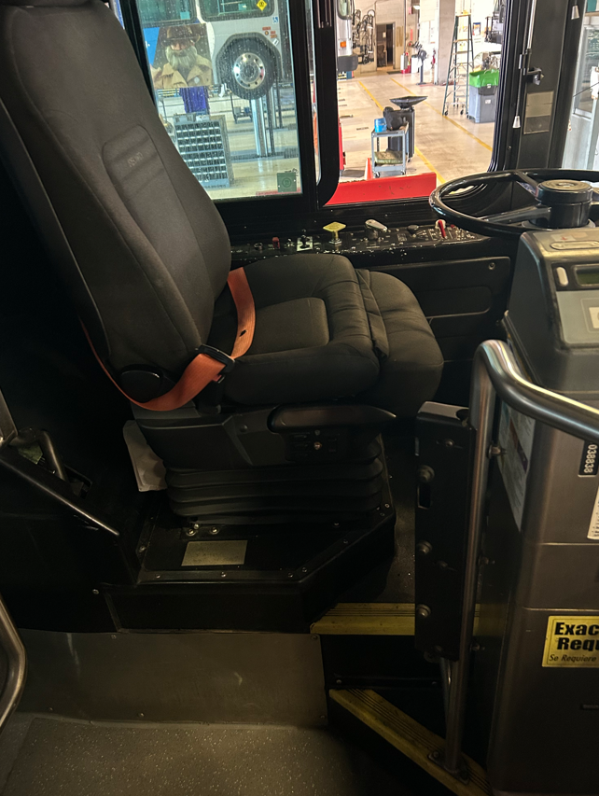
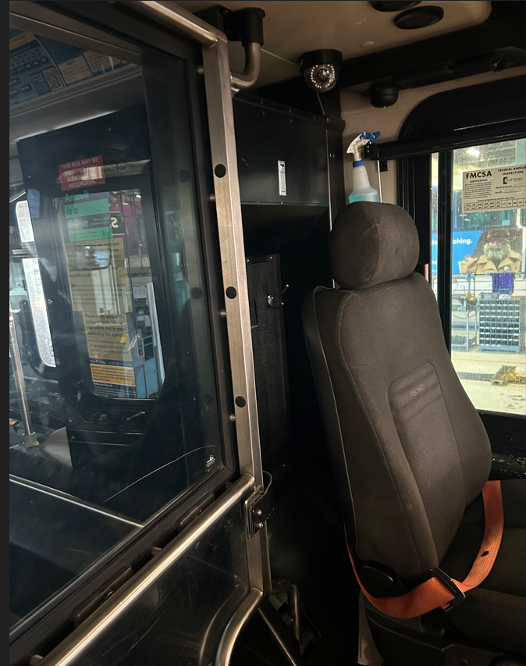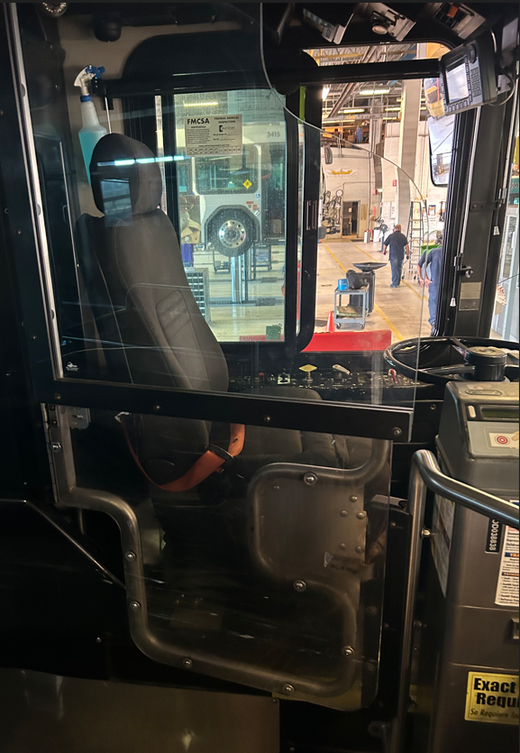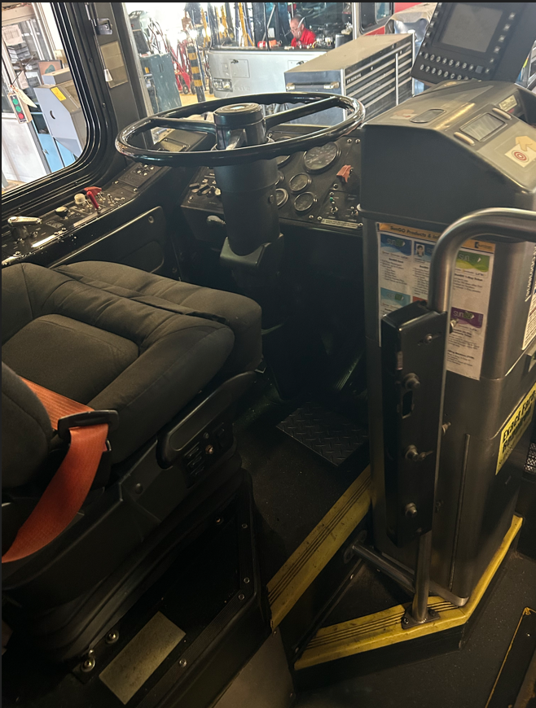

ALL OTHER PROVISIONS OF THE REQUEST FOR PROPOSAL SHALL REMAIN IN THEIR ENTIRETY.
OFFEROR HEREBY ACKNOWLEDES RECEIPT AND UNDERSTANDING OF THE ABOVE AMENDMENT.

____________________________________ ____________________________________
Signature Date Company Name

____________________________________ ____________________________________
Printed Name and Title Address

____________________________________
City State Zip

